Foresight Synergy Network

Impact of Advanced Information Technologies
On the Governance of the State:
Final Workshop Guidelines

Friday May 31, 2019
13:00 – 16:00

University of Ottawa
Telfer School of Management
Desmarais Building Room 7170
55 Laurier Ave E

Table of Contents

Context
Workshop Objectives
Challenge Questions for Developing Scenarios
Approach to Date
- Step 1: Framing the problem
- Step 2: Current assumptions
- Step 3: Search for weak signals
- Step 4: Select change drivers
- Step 5: Test assumptions and identify challenges
- Step 6: Develop scenarios
Workshop Procedures
Next Steps
- Step 7: Facilitated Summary & Discussion about Current Scenarios
- Step 8: Reassess Assumptions & Challenges
- Step 9: Document Discussion
Annexes
Annex 1: Approaches to “Viewing the Future”
Annex 2: Selected Bibliography

Impact of Advanced Information Technologies
On the Governance of the State:
Final Workshop Guidelines

Context
This is the 3rd and final workshop in a series addressing the topic of the Impact of Advanced Information Technologies on the Governance of the State. The term ‘state’ is taken to be all forms of national governance structures ranging from autocracies to democracies.
Autocratic states are using advanced information technologies to monitor citizens in unprecedented ways. Democracy is under threat. Fake news and alternative facts are increasingly penetrating the public commons. Cyberspace is becoming an environment for nefarious actions by both state and non-state actors seeking many conflicting objectives ranging from eavesdropping and espionage to influencing public processes such as elections.
This workshop series is a consequence of two past Foresight seminars late last year, namely Technology & Democracy on November 23rd and The History & Foreseeable Future of Artificial Intelligence: Opportunities & Threats on December 14th. Both seminars raised issues that led to staging this Workshop series. The presentation materials for both seminars and the previous two workshops are available on the FSN website on the dates noted (https://fsncanada.wordpress.com/).
Workshop Objectives
Nine scenarios have been developed in the first two Workshops; three for each timeframe, where the timeframes are the next 10 years, 2030 - 2050, and 2050 - 2100. This 3rd workshop seeks to consolidate results to date into one scenario per timeframe using the process outlined here on the basis of the ‘most likely case’. Additional effort will be made to reach consensus on ‘worst case’ and ‘best case’ scenarios given the material at hand.
Challenge Questions for Developing Scenarios
The following four questions were used to frame the development of the scenarios:
- What are the emerging threats to governance of the state posed by advanced IT?
- What are the emerging benefits to governance of the state posed by advanced IT?
- What disruptors are possible wrt using advanced IT to impact the governance of the state?
- What wild cards are possible wrt using advanced IT to impact the governance of the state?

Approach to Date
Here are the steps we have moved through:
Step 1: Framing the problem
The framing of the problem may change as we learn more about the multiple pathways through which drivers could impact the system.
Step 2: Current assumptions
Identifies the current, commonly held assumptions about the issue or problem under study. These are the core assumptions that are shaping public policy and public dialogue on the issue.
Step 3: Search for weak signals
The focus is on finding weak signals that could indicate a significant change is possible or underway. Weak signals that appear to have a significant potential for disruption are further developed into insights.
Step 4: Select change drivers
All the insights from the signal scanning phase are reviewed, and those that appear to have a significant, disruptive impact on at least one of the elements in the system map are chosen as change drivers for the scenario exercise.
Step 5: Test assumptions and identify challenges
- Identified Key Lens to view the problem being addressed (i.e., labels for the orthogonal axes)
- Established four Challenge Questions
- Identified what drives the Challenge Questions
- Identified possible Disruptors and Wild Cards
  - events which may challenge the occurrence of “highly probable” situations in the future
- Populated scenarios using orthogonal axes approach
- Reported scenarios to Plenary sessions
Step 6: Develop scenarios
For each scenario, an archetype and scenario logic are customized to explore strategically useful futures. The state of each driver and insight is deduced from the scenario logic. Then the state of each system element is deduced from all of the preceding steps. At this point the participants can see what the system could look like under the given conditions. These end-state scenarios offer a vivid snapshot of the key system elements for each future.

Workshop Procedures
The following steps are proposed for conducting this the 3rd Workshop:
- Review, discuss, and refine this Guide as appropriate
- Develop a group consensus on backcasting for ‘most likely case’ scenarios per timeframe
- Develop a group consensus on ‘worst case’ and ‘best case’ scenarios
- Identify leverage points in each scenario
- Additional group comments
Next Steps
Step 7: Summary & Discussion of the nine scenarios
The chart template below has been used to categorise the orthogonal axes. The horizontal axis label was used by each working group; however the vertical axis was labelled in different ways with the terms used below. These appear to be common sets of terms for each end of the axis and have subsequently been adopted here to reflect a similar endpoint.
Figure 1: Quadrant Chart Template
Autocracy
Democracy
Open/Commons/Decentralised/Transparent
Closed/Private/Centralised/Opaque

The following three charts integrate the content from all of the working groups, in both the March 18th and March 25th sessions, into a common chart version for each of the three timeframes. The versions attempt to faithfully represent the original flipchart text and placement with the following exceptions: a) if the original flipchart text was unclear we have annotated it as “(?)”, and b) a few entries needed to be repositioned slightly due to space limitations around similarly placed entries. Questions about the meaning and broader interpretation of some entries will be the subject of the forthcoming workshop and subsequent revisions.

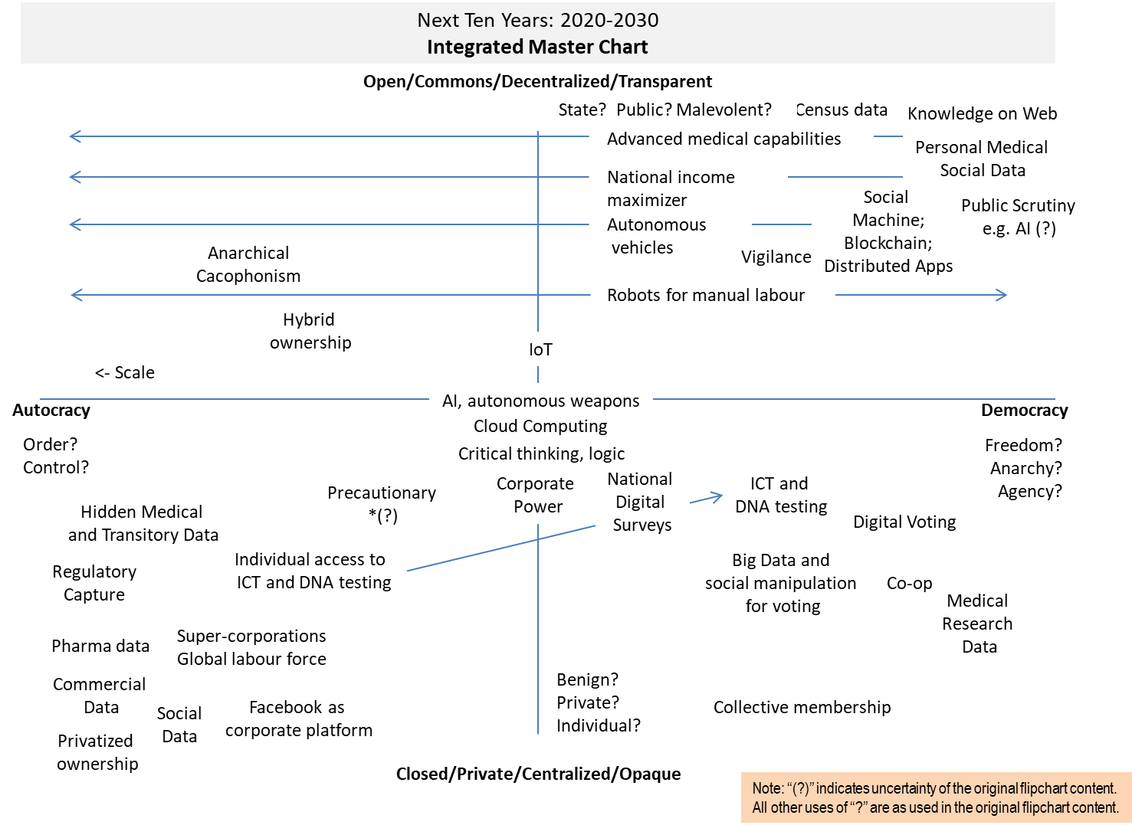
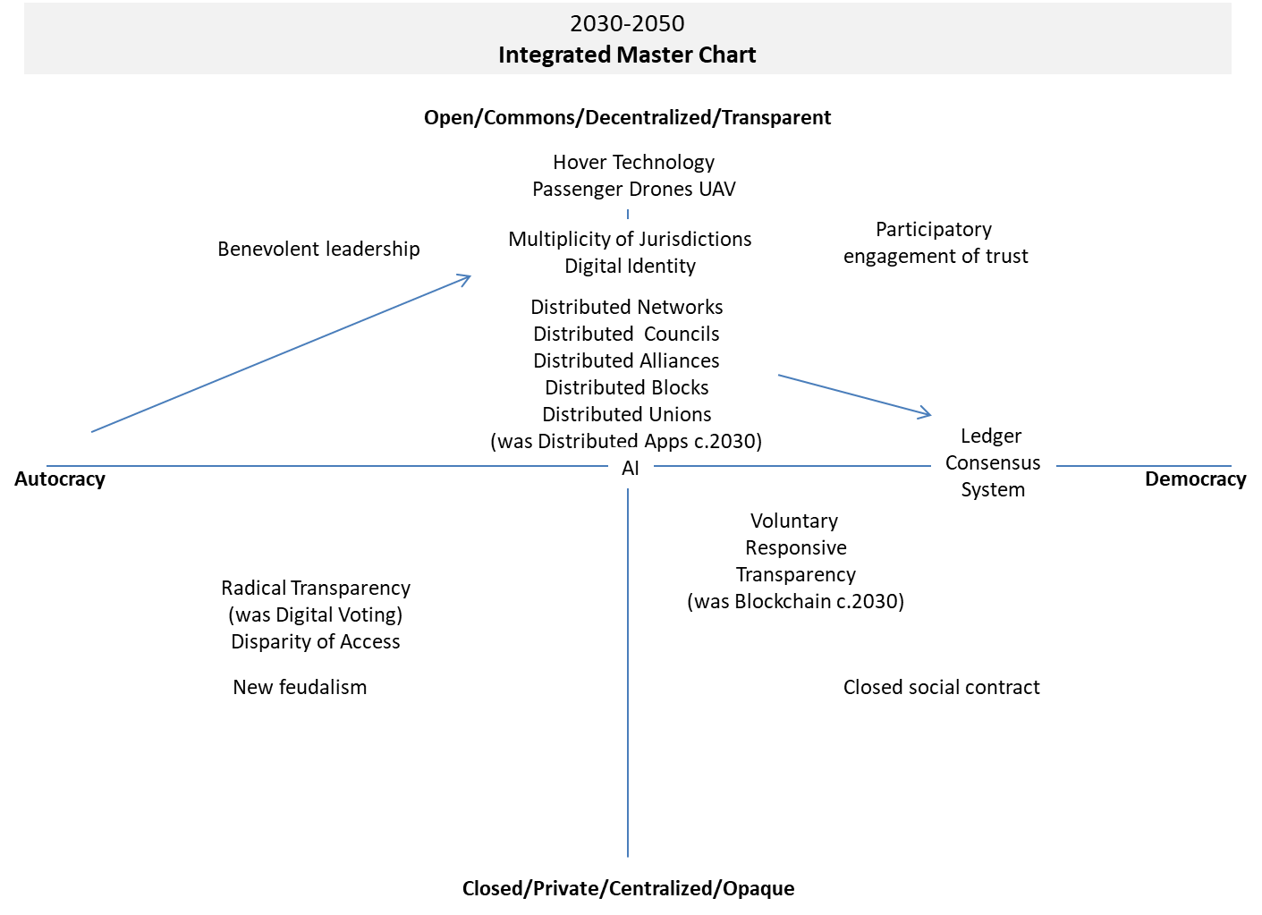
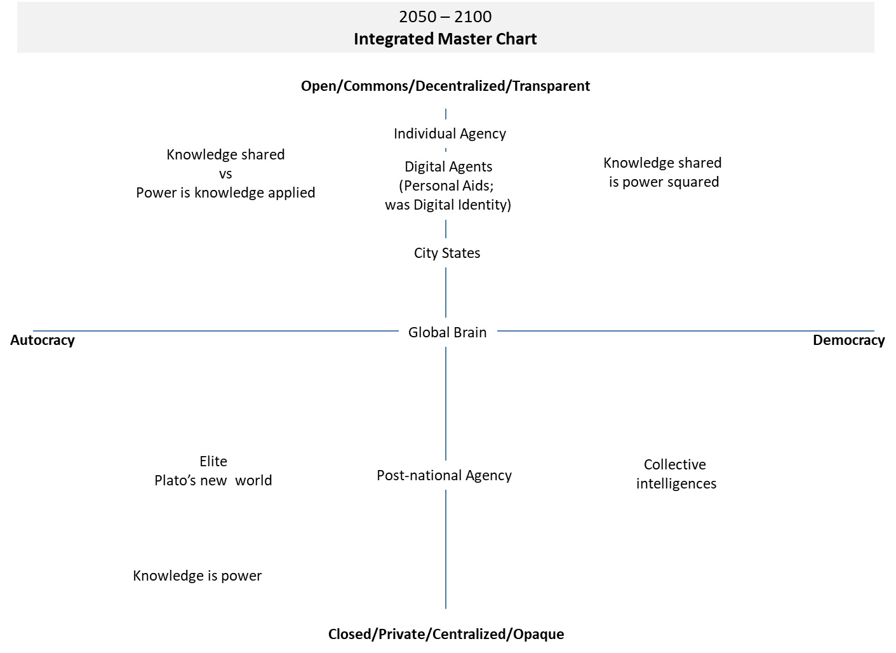
Step 8: Reassess Assumptions & Challenges
In reviewing the current scenarios participants are reminded to reassess the assumptions and challenges from the earlier workshops.
Step 9: Document Discussion
The workshop facilitators will document the discussion with a view to refining our collective views on the topic at hand and will prepare a report for circulation and comment among FSN participants.

Annex 1
Approaches to “Viewing the Future”
In general, there are three basic techniques widely used to identify possible future conditions. One is a top-down approach; it involves the use of “scenarios” that postulate certain circumstances about the future and then draw some likely implications from those circumstances. The second is a bottom-up approach; it draws future implications from early warning signals, which are based either on the extrapolation of current data and trends, or on the observations of knowledgeable individuals-so-called “look-out panels.” The third is scanning, which involves a continual, planned, deliberate, and thorough review of selected published information, and contacts with other “futures watching” organizations.
Scanning versus Foresight
Scanning identifies changes in the domestic and international environments that could affect policy and programs.
Foresight explores how these changes may evolve and interact to create new policy challenges and opportunities. The objective of foresight is to explore plausible, alternative futures and identify the challenges and opportunities that may emerge. Foresight helps us understand the forces shaping a system, how the system could evolve and what surprises could arise. This analysis provides a valuable context for the development of policies and strategies that are robust across a range of plausible futures. It also provides a solid foundation for vision-building.
(Source: http://horizons.gc.ca/eng/book/export/html/2705)

Annex 2
Selected Bibliography

Foresight Training Manual: Module 1 - Introduction to Foresight
Available at: http://horizons.gc.ca/eng/book/export/html/2705

List of forms of government
Available at: https://en.wikipedia.org/wiki/List_of_forms_of_government

Corporatocracy
Available at: https://en.wikipedia.org/wiki/Corporatocracy

Artificial intelligence and the future of geopolitics
Available at: www.brookings.edu/blog/techtank/2018/11/14/artificial-intelligence-and-the-future-of-geopolitics/

Geopolitics of artificial intelligence: the return of empires?
Nicolas Miailhe, Foreign Policy 2018/3 (Fall), pages 105 to 117, available at: www.cairn.info/article.php?ID_ARTICLE=PE_183_0105

The Silk Roads become digital
Oboreurope, February 28, 2018, available at: www.oboreurope.com

An Overview of National AI Strategies - Politics + AI – Medium
T. Dutton, Medium, available at: https://medium.com

Summary of the 2018 White House Summit on Artificial Intelligence for American Industry
Washington DC, May-White, May 10, 2018, available at: www.whitehouse.gov

The new geopolitics of artificial intelligence
Available at: www.weforum.org/agenda/2018/10/artificial-intelligence-ai-new-geopolitics-un/

The Geopolitics of Artificial Intelligence
Jayshree Pandya, Contributor Jan 28, 2019, available at: www.forbes.com/sites/cognitiveworld/2019/01/28/the-geopolitics-of-artificial-intelligence/#41a6efb179e1

Robot Wars: US Empire and geopolitics in the robotic age
Ian GR Shaw, University of Glasgow, UK August 31, 2017, available at: https://journals.sagepub.com/doi/full/10.1177/0967010617713157

AI, China, Russia, and the Global Order: Technological, Political, Global, and Creative Perspectives (A Whitepaper), edited by D. Nicolas and Wright, 218 pp., Washington DC: Department of Defense, A Strategic Multilayer Assessment (SMA) Periodic Publication. December 2018, available at: https://nsiteam.com/social/wp-content/uploads/2018/12/AI-China-Russia-Global-WP_FINAL.pdf)

China: Determined to dominate cyberspace and AI
Chris C. Demchak, April 29, 2019, Bulletin of the Atomic Scientists, available at: https://thebulletin.org/2019/04/china-determined-to-dominate-cyberspace-and-ai/

Warring State: China’s Cybersecurity Strategy
Chang, A. 2014, Washington, DC: Center for New America Security, available at: www.cnas.org/chinas-cybersecurity-strategy#.VeHZlM5RErs
Four Horsemen of AI Conflict: Scale, Speed, Foreknowledge, and Strategic Coherence
C. Demchak, in AI, China, Russia, and the Global Order: Technological, Political, Global, and Creative Perspectives (A Whitepaper), edited by D. Nicolas and Wright, 94–101. Washington DC: Department of Defense, A Strategic Multilayer Assessment (SMA) Periodic Publication. December, chapter 13, available at: https://nsiteam.com/social/wp-content/uploads/2018/12/AI-China-Russia-Global-WP_FINAL.pdf)

Cybered Conflict vs. Cyber War
Demchak, C. 2010, Atlantic Council Issue Brief, October 20, available at: www.atlanticcouncil.org/blogs/new-atlanticist/cybered-conflict-vs-cyber-war
China and the Shaping of African Information Societies
Gagliardone, I. 2015, in Africa and China: How Africans and Their Governments are Shaping Relations with China, edited by A. W. Gadzala, 45–61. New York: Rowman & Littlefield, [see: Google Scholar]

The Economic Foundations of Cyber Strategy: Changing Game Structure of Multi-level Cyber Conflict, Mallery, J. 2018, Research presentation, Systemic Cyber Defense workshop, US Naval War College, Newport, RI (May 1), [see: Google Scholar]
Authoritarian Practices in the Digital Age - The Contestation and Shaping of Cyber Norms through China’s Internet Sovereignty Agenda
McKune, S., and S. Ahmed. 2018, International Journal of Communication 12: 21, [see: Google Scholar]

The Hacked World Order: How Nations Fight, Trade, Maneuver, and Manipulate in the Digital Age
Segal, A. 2016, New York City, NY: Public Affairs, [see: Google Scholar]

The Economic Rise of China: Rule-Taker, Rule-Maker, or Rule-Breaker?
Wang, Z. 2017, Asian Survey 57 (4): 595–617. doi:10.1525/as.2017.57.4.595, [see: Google Scholar]

The geopolitics of artificial intelligence
Available at: www.washingtonpost.com/news/theworldpost/wp/2018/09/28/artificial-intelligence-3/?utm_term=.9594a9b2f87b

